**Part 2 Text**

When creating a web page you add tags (known as markup) to the contents of the page. These tags provide extra meaning and allow browsers to show users the appropriate structure for the page.

**HEADINGS Exercise**

HTML has six levels of headings. Type this into Notepad++.

<!DOCTYPE html>

<html>

<head>

<title>Headings HTML</title>

</head>

<body>

<h1>This is a Main heading</h1>

<h2>This is a Level 2 heading</h2>

<h3>This is a Level 3 heading</h3>

<h4>This is a Level 4 heading</h4>

<h5>This is a Level 5 heading</h5>

<h6>This is a Level 6 heading</h6>

</body>

</html>

**Save this as headings.html Change the save as type to All types**

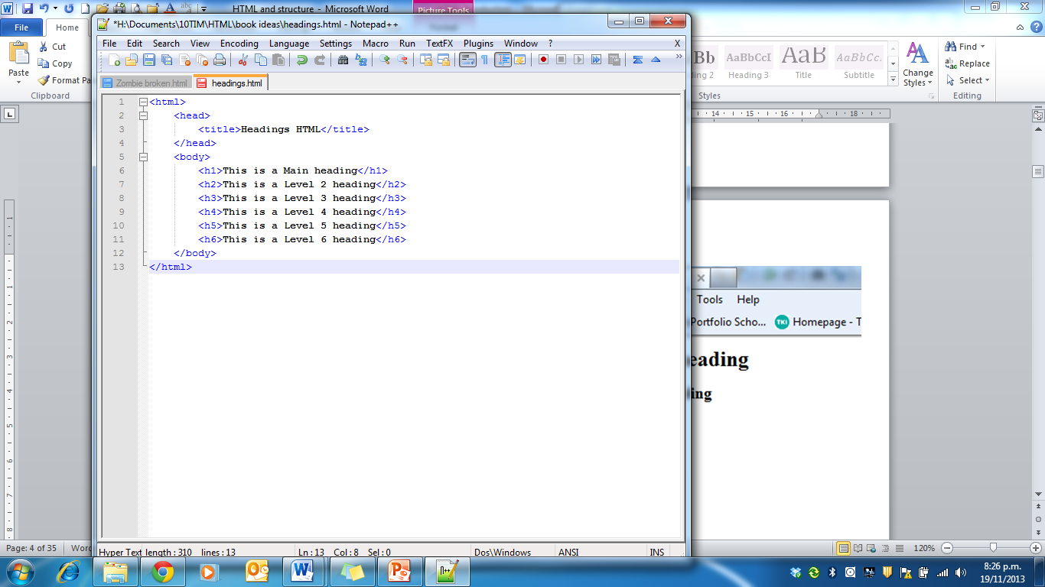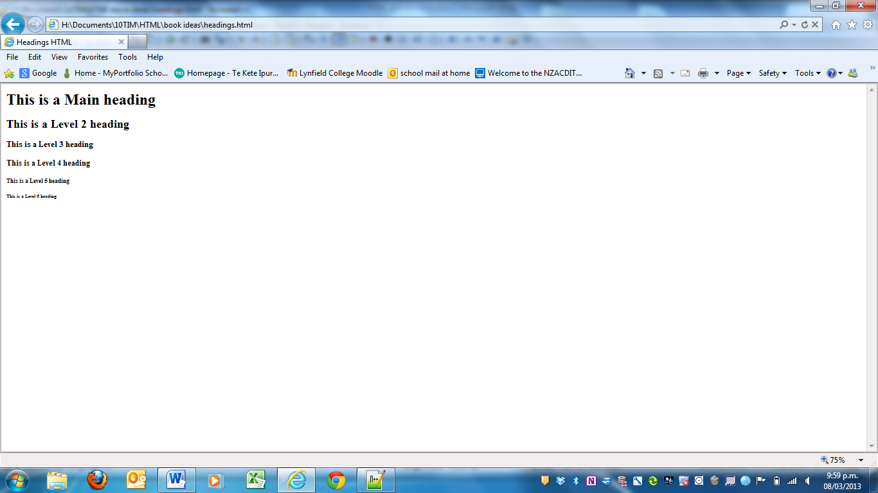

**PARAGRAPHS <p>**

A paragraph consists of one or more sentences that form a self-contained unit of discourse. The start of a paragraph is indicated by a new line.

Text is easier to understand when it is split up into units of text. For example, a book may have chapters. Chapters can have subheadings. Under each heading there will be one or more paragraphs.

To create a paragraph, surround the words that make up the paragraph with an opening <p> tag and closing </p> tag.

By default the browser will show each paragraph on a new line with some space between it and any subsequent paragraphs.

**Exercise**: use the <p> tag to create a paragraph on a web page. Save as paragraphs.html

**The coding**

<!DOCTYPE html>

<html>

<head>

<title>Paragraphs</title>

</head>

<body>

<p>A paragraph consists of one or more sentences that form a self-contained unit of discourse. The start of a paragraph is indicated by a new line.</p>

<p>Text is easier to understand when it is split up into units of text. For example, a book may have chapters. Chapters can have subheadings. Under each heading there will be one or more paragraphs.</p>

</body>

</html>

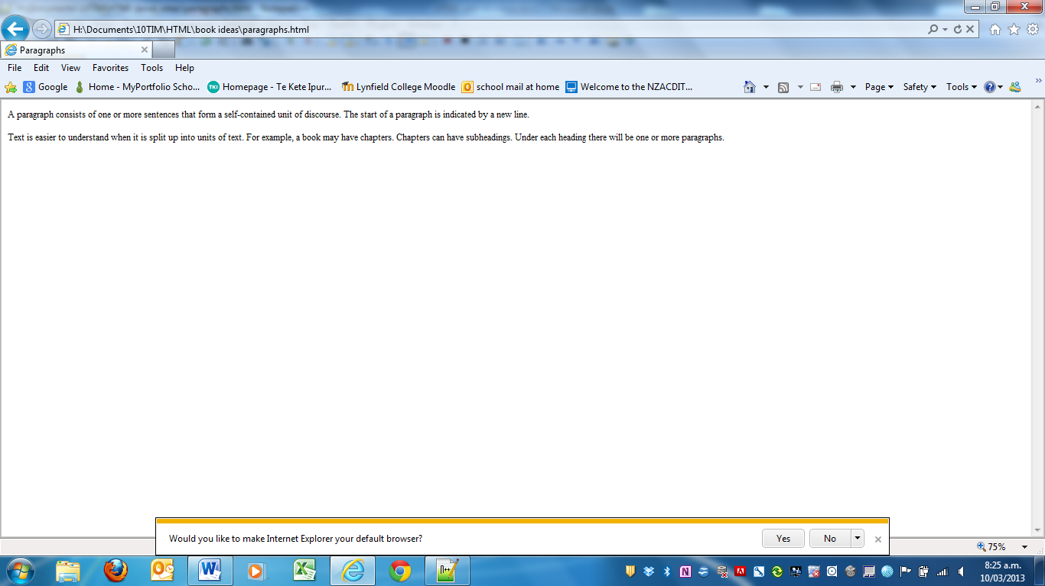**The result**